 East West University

**Department of CSE**

**LAB REPORT**

|  |  |
| --- | --- |
| **Course Code and Name:** CSE-209 Electrical Circuits | |
| **Experiment no:** 01  **Group**-07 | |
| **Experiment name:** Introduction to Circuit Elements and Variables | |
| **Name of Students** |  |
| Ishfaf Zaman Khan |  |
| **ID**: 2023-3-60-**338** | **Course Instructor information:**  M. Saddam Hossain Khan |
| Sumya Kawsar | Senior Lecturer |
| **ID**:2023-3-60-**168** | Department of Computer Science and  Engineering |
| Md. Hasib Ali |  |
| **ID**:2023-3-60-**186** |  |
| Date of Submission: 11th March, 2025 | **Pre-lab marks:** |
| **Post-lab marks:** |
| **Total marks:** |

**Experiment Title:** Introduction to Circuit Elements and Variables.

**Abstract:**

From this experiment, we get to understand basic circuit elements like voltage, current, and resistance and how to measure them using tools like voltmeters, ammeters, and multimeters. The goal is to learn how these components work together and to check if Ohm’s Law holds true. To do this, a simple circuit is built, and voltage and current values are recorded and analyzed. The results show small differences between the expected and measured values due to minor errors. Overall, this experiment provides a hands-on way to learn about electrical circuits and measurement techniques.

**Objective:**

* To understand basic circuit variables such as voltage and current.
* To become familiar with circuit elements like voltage sources and resistors.
* To learn how to measure voltage, current, and resistance using voltmeters, ammeters, and multimeters.
* To verify Ohm’s Law by analyzing the relationship between voltage and current.
* To develop practical skills in constructing and analyzing simple electrical circuits.

**Theory and Experimental Methods**

**Theory:**

In an electric circuit, elements are categorized as active or passive. Active elements, such as voltage sources, provide energy, whereas passive elements, like resistors, consume energy. The fundamental circuit variables include current (measured in Amperes, A) and voltage (measured in Volts, V).

According to Ohm’s Law, the relationship between voltage (V), current (I), and resistance (R) is given by:

V = IR (1)

This equation implies that for a given resistance, the voltage across a component is directly proportional to the current flowing through it.

To measure these values:

* Ammeter is connected in series to measure current.
* Voltmeter is connected in parallel to measure voltage.
* Multimeter is used to measure resistance.

**Experimental Methods:**

1. The resistance of the supplied resistor was measured using a multimeter and recorded.
2. A simple circuit was constructed, as shown in the circuit diagram.
3. The DC voltage source was set to different values (5V, 6V, 7V, 8V, 9V, and 10V).
4. The corresponding current (I) and voltage (V) values were measured and recorded.
5. The collected data was analyzed to verify Ohm’s Law by plotting V vs. I and determining the resistance from the slope.
6. The theoretical values were compared with the experimental values, and discrepancies were noted.

**Circuit Diagram:**

**Figure-1:**

**V**



+

**E**

DC

**V**

I

DC

**A**

**R = 1000**Ω

**Experimental Datasheet:**

|  |  |  |  |  |
| --- | --- | --- | --- | --- |
| **Observation Number** | **Set Value of E (V)** | **Measured Value of V (V)** | **Measured Value of I (mA)** | **Measured Value of R (Ω)** |
| 1 | 5 | 5 | 4.8 | 987 |
| 2 | 6 | 6 | 5.9 |
| 3 | 7 | 7 | 7 |
| 4 | 8 | 8 | 7.9 |
| 5 | 9 | 8.9 | 8.9 |
| 6 | 10 | 9.96 | 10 |

**Post Lab Questions**

# Theoretically calculate the values of I, using measured values of Vand R. Compare the theoretical values with the measured values and comment on any discrepancy.

**Solution:**

|  |  |  |  |
| --- | --- | --- | --- |
| **Observation  Number** | **Measured Value of V (V)** | **Measured Value Of R (Ω)** | **Theoretically  Calculated Value of I (mA)** |
| **1** | 5 | **987** | 4.8 |
| **2** | 6 | 5.9 |
| **3** | 7 | 7 |
| **4** | 8 | 7.9 |
| **5** | 8.9 | 8.9 |
| **6** | 9.96 | 10 |

Comparison between theoretically calculated values and measured values:

|  |  |  |
| --- | --- | --- |
| **Observation Number** | **Theoretically Calculated Value of I (mA)** | **Measured Value of I (mA)** |
| 1 | 4.8 | 5 |
| 2 | 5.9 | 6 |
| 3 | 7 | 7 |
| 4 | 7.9 | 8 |
| 5 | 8.9 | 9 |
| 6 | 10 | 10 |

This comparison shows that there are some differences between theoretically calculated values and measured values of **I.** The theoretical values and the measured values can be varied. And that’s happened because of Instrument resolution or zero offset or Instrument drift or Personal errors.

# Theoretically calculate the values of *R* from the measured values of *V* and *I* using Ohm’s law. Compare the calculated and measured of *R* and comment on any discrepancy.

**Solution:**

We know, Ohm’s Law is,

⇒

For V = 5V and I = 5mA,

For V = 6V and I = 6mA,

For V = 7V and I = 7mA,

For V = 8V and I = 8mA,

For V = 8.9V and I = 9mA,

For V = 9.96V and I = 10mA,

Comparison between theoretically calculated values and measured values:

|  |  |  |
| --- | --- | --- |
| **Observation Number** | **Theoretically Calculated Value of R (KΩ)** | **Measured Value of R (KΩ)** |
| 1 | 1 KΩ | 0.987 KΩ |
| 2 | 1 KΩ |
| 3 | 1 KΩ |
| 4 | 1 KΩ |
| 5 | 0.988 KΩ |
| 6 | 0.996 KΩ |

This comparison shows that there are some discrepancies between theoretically calculated values and measured values of **R.** The theoretical values and the measured values vary. When the resistance calculated using Ohm's law was compared to the one measured in the experiment, it was noted that they didn't always match up. This could be attributed to potential inaccuracies in the tools used, or to the condition of the wires and connections within the circuit. Variations in resistance were observed due to factors such as temperature changes, and errors may have been introduced during setup or while recording the results. Thus, it is emphasized that caution should be exercised, and thorough double-checking of all aspects is essential when conducting experiments of this nature.

# Compare the set value of E and the measured value of *V* and comment on any discrepancy.

**Solution:**

|  |  |  |
| --- | --- | --- |
| **Observation Number** | **Set Value of E (V)** | **Measured Value of V (V)** |
| 1 | 5 | 5 |
| 2 | 6 | 6 |
| 3 | 7 | 7 |
| 4 | 8 | 8 |
| 5 | 9 | 8.9 |
| 6 | 10 | 9.96 |

This comparison shows that there are some discrepancies between the set values of **E** values and the measured values of **V.** The theoretical values and the measured values vary.

# Plot V vs. (taking I as an independent variable) and fit a straight line passing through the origin. From the plot, determine the resistance of the supplied resistor using Ohm’s law. Compare this value with the measured value and comment on any discrepancy.

# Solution:

# Figure:

**Plot: 1**

Here, x1 = 5 , y1 = 5

x2 = 9.96 , y2 = 10

Thus, the measured values and the theoretical values are not accurate.

# Discuss how voltage or current is measured using a multirange meter

# Solution:

A multirange meter is used to measure current and resistance across different ranges, and an analogue voltmeter was used to measure voltage. To measure voltage or current accurately, the correct range must be selected.

1. Measuring Voltage (Using an Analog Voltmeter):

* The voltmeter was set to the DC voltage (V) mode.
* The correct voltage range was selected to ensure an accurate reading.
* The voltmeter was connected in parallel with the circuit element.
* The needle position on the scale was observed to determine the voltage.

1. Measuring Current (Using a Multimeter):

* The multimeter was set to the DC current (A or mA) mode.
* The correct range was chosen to avoid damage.
* The multimeter was connected in series with the circuit.
* The digital display showed the measured current value.

# Results and Discussion

In this experiment, we plotted Voltage(V) against Current (I) to find the resistance of a resistor using Ohm's Law (V = IR). The graph should be a straight line starting from zero, and its slope gives the resistance. Here, the slope was 1008 Ω. However, the measured resistance in the first observation was 987 Ω, which is slightly different. This small difference might be due to mistakes in measuring voltage or current, or the resistor's actual value might not be exactly the same. Overall, the results are close, showing the experiment was done well, but better measurements could make the results even more accurate in the future.

# Conclusion

When we are taking the values of voltage and current from the voltmeter and ammeter, we have to be careful in taking values. The connection of voltmeter and ammeter should be connected correctly, if there is any fault in set up, then it will show wrong answer and sometimes instruments burn.

**Pre-lab of Group Members:**

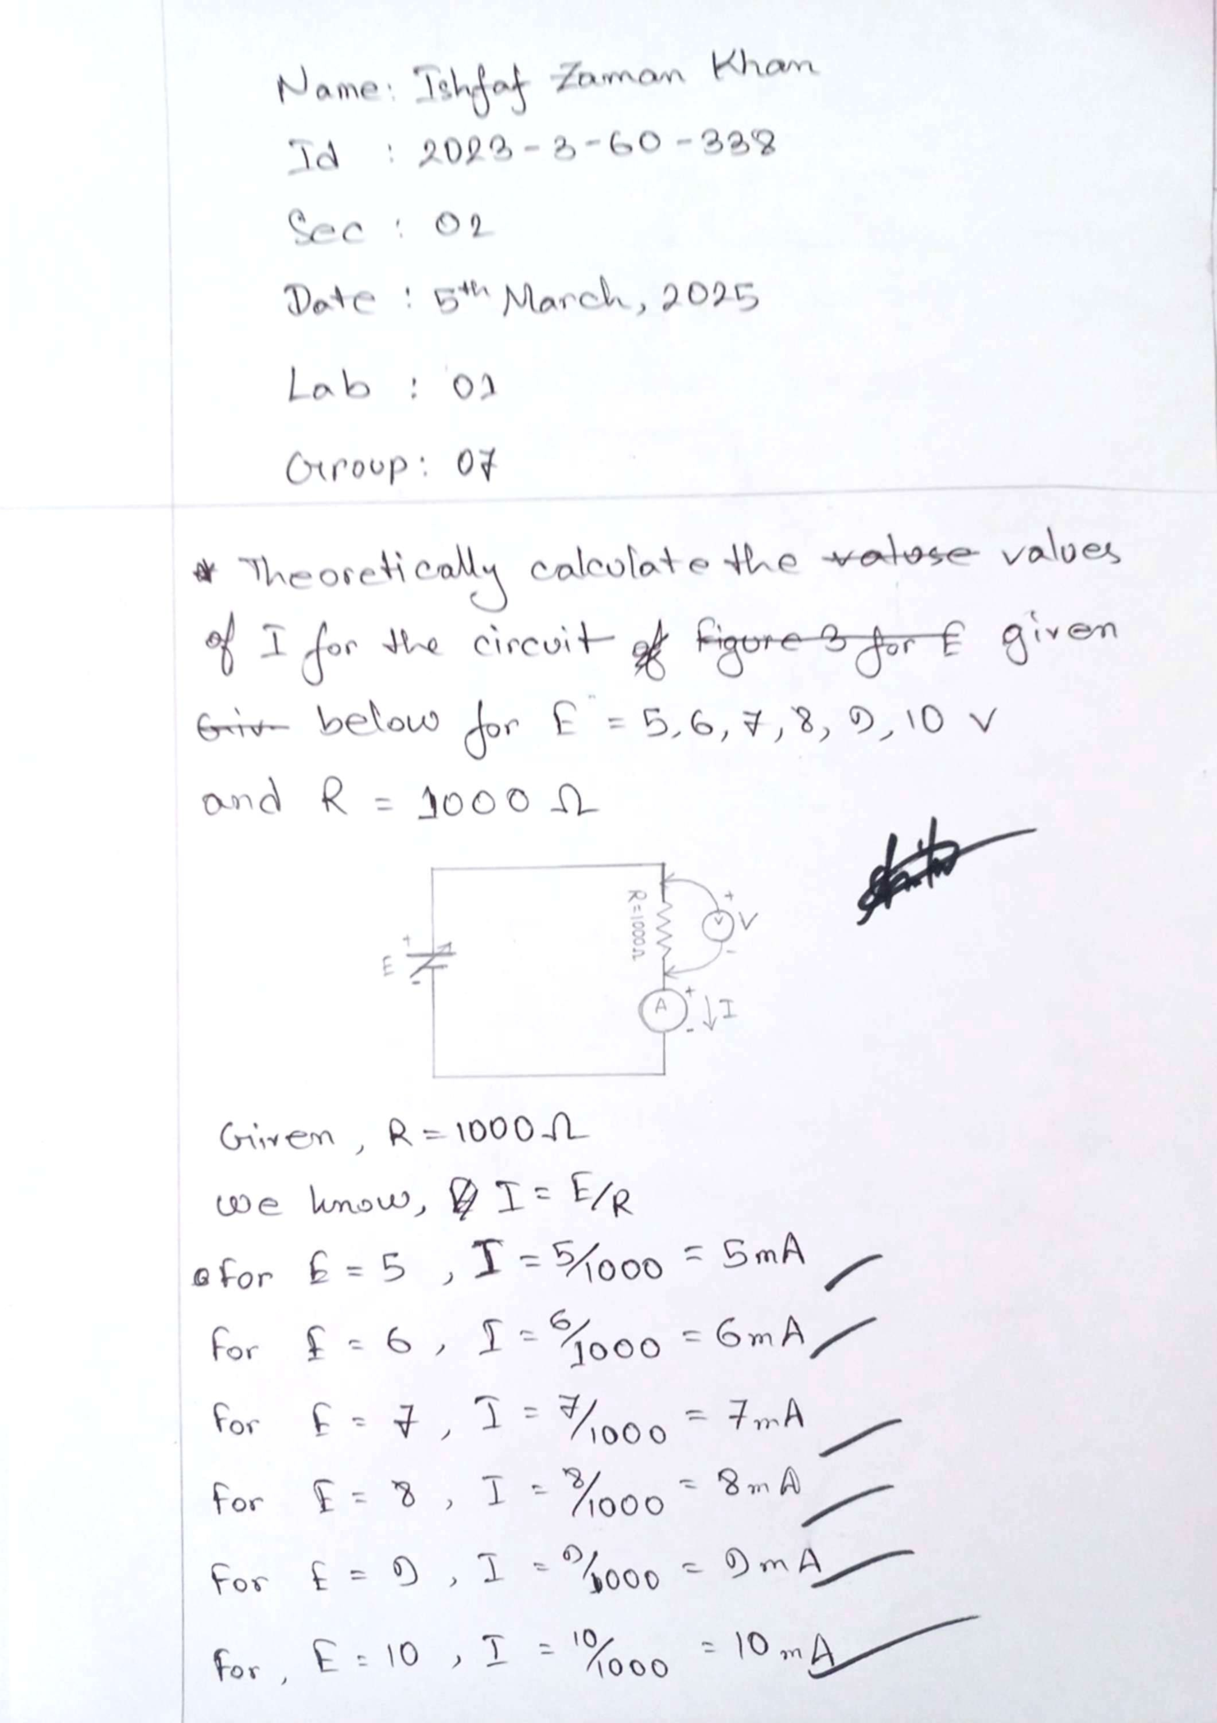

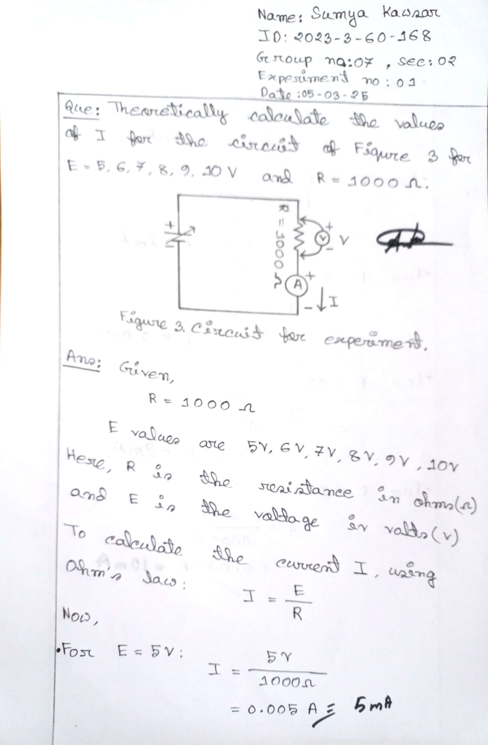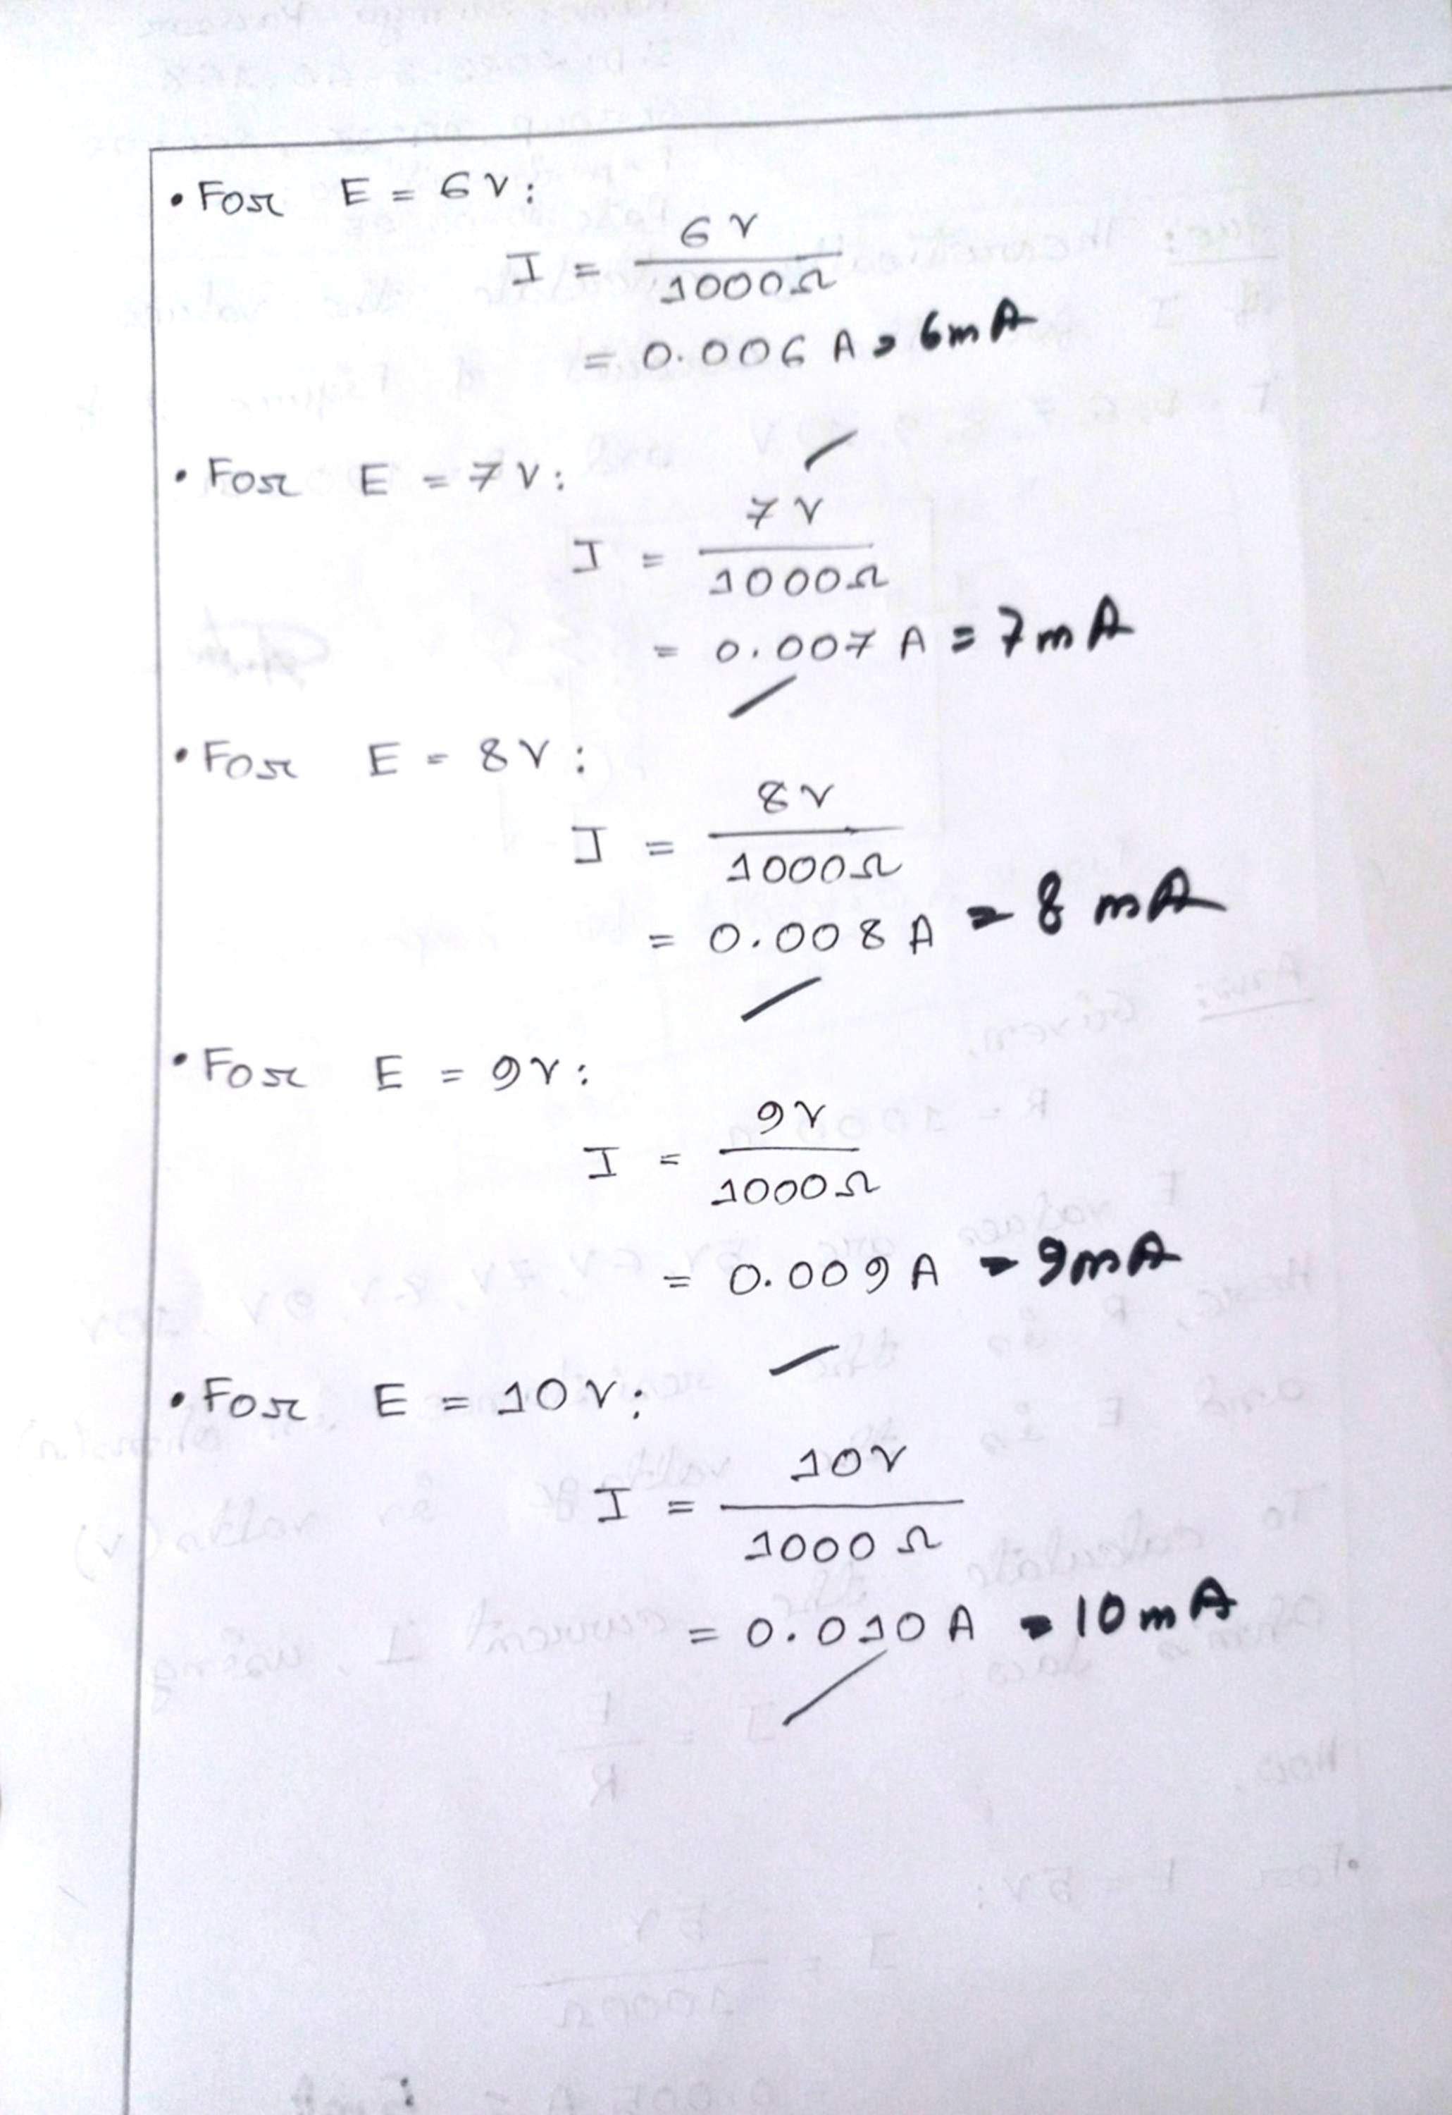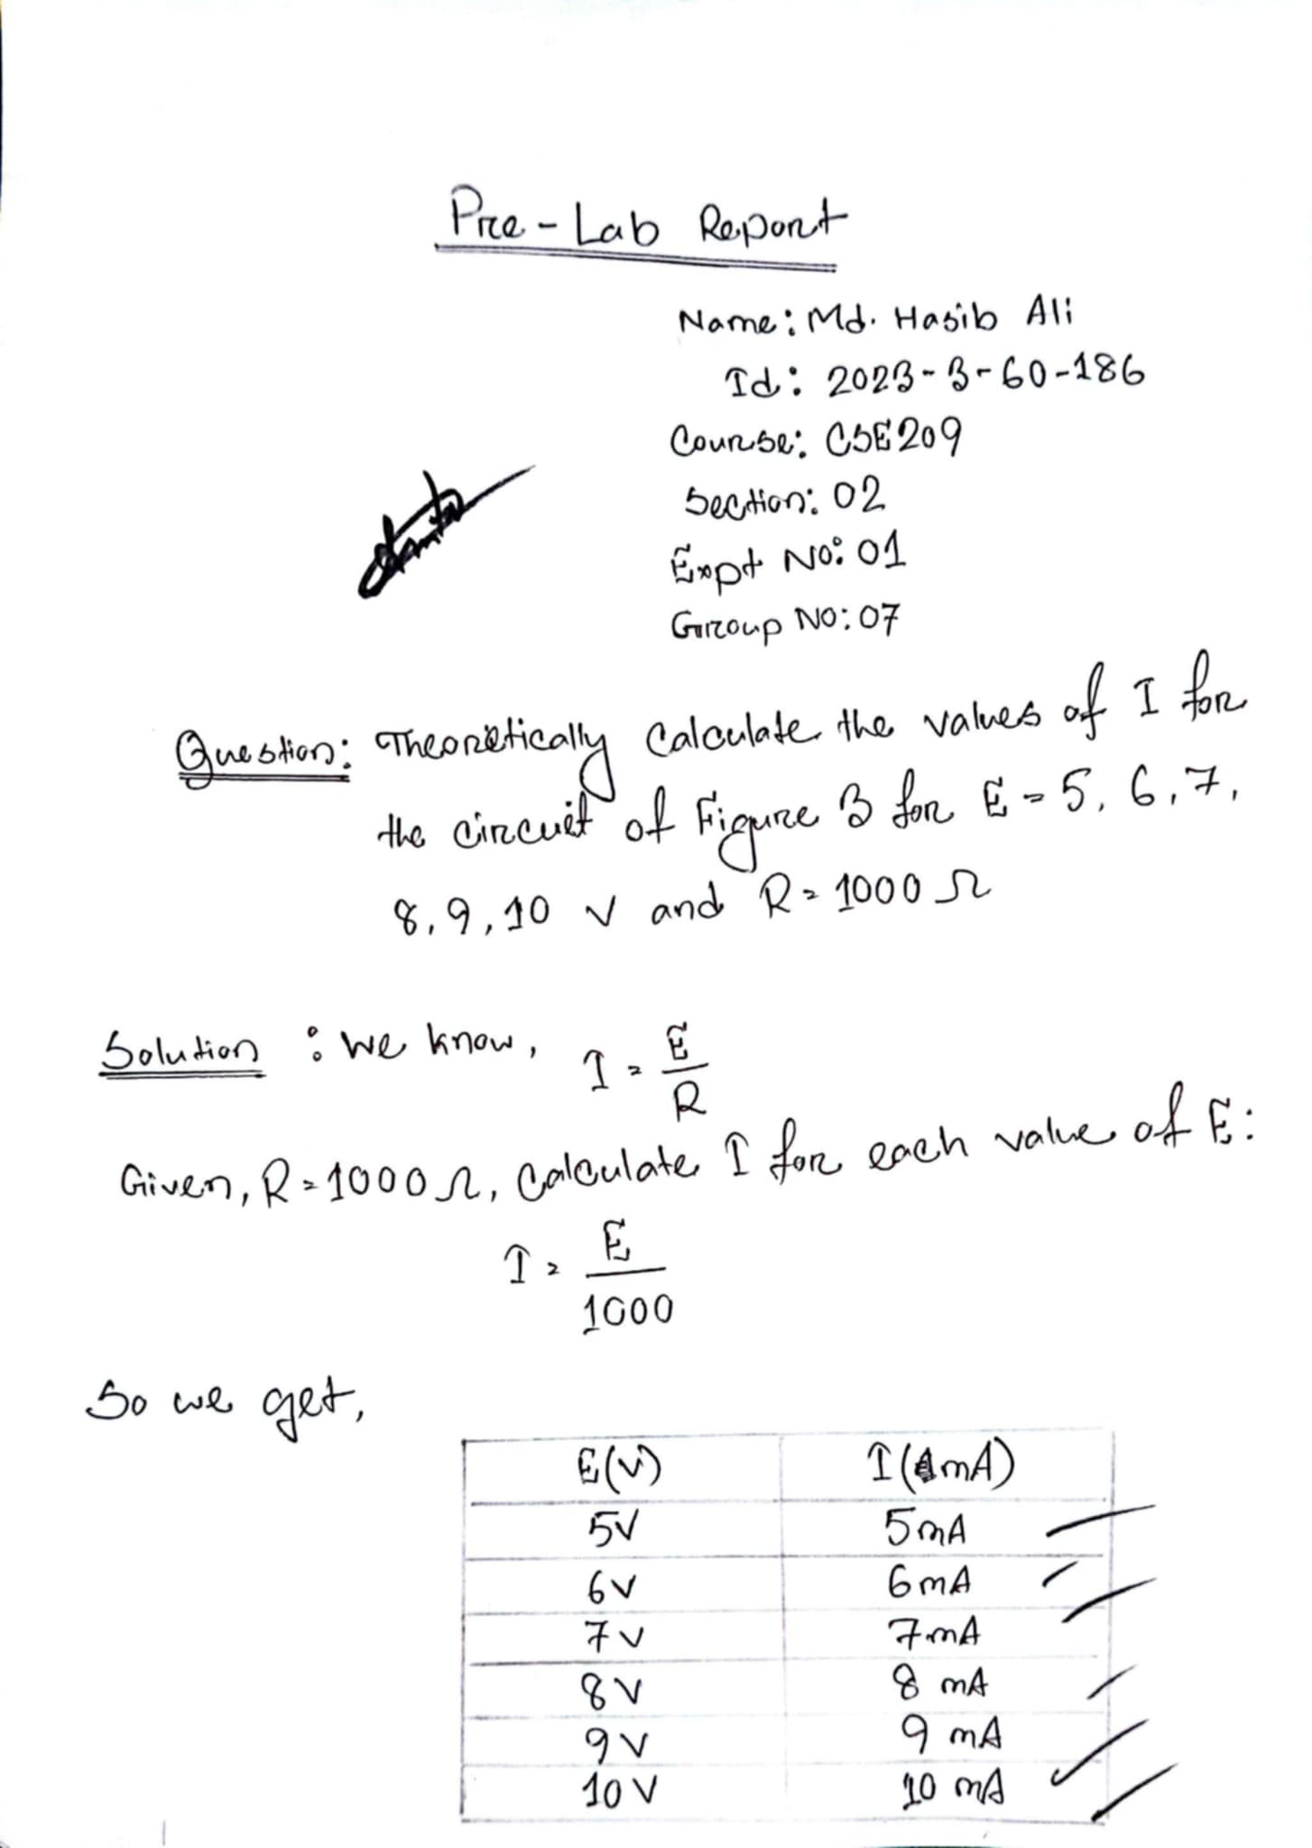

**Experimental Datasheet:**

